Career Guidance
“The real tragedy of the poor is the poverty of their aspirations”- Adam Smith
Introduction:
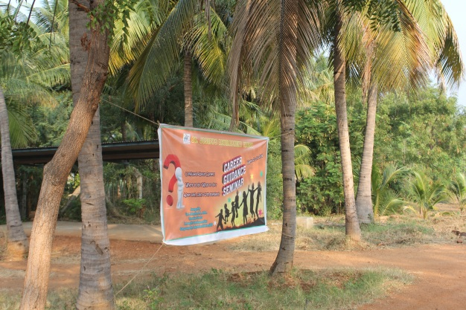
The above mentioned quote is very perfect for every person who is stricken with poverty. People might have been born poor but it is not necessary that they have to die poor. This condition can definitely be changed if they have great aspiration to become someone in the future. This aspiration is the basic and vital for everyone. This program was organized in order to imbibe the spirit in all the participants to aspire high and work towards actualizing it.
Participants:
There were 49 participants on the whole for the day from three different orphanages.
Insitution | 10th Std | 11th Std | 12th Std | Total
Puthupunal | 8 | 6 | 7 | 21
Puthuvasantham | 8 | 6 | 0 | 14
Puthuirudayam | 8 | 3 | 3 | 14
Total | 24 | 15 | 10 | 49

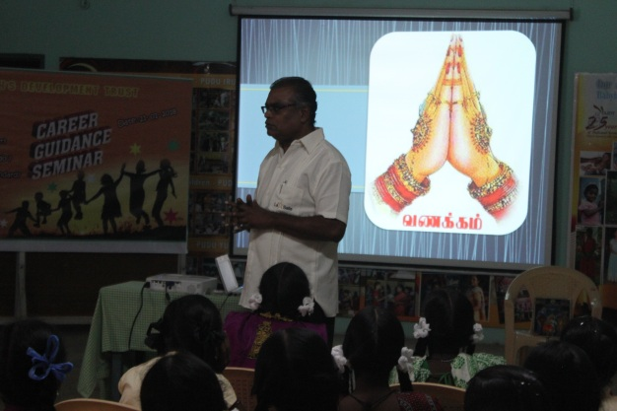
Bro. Arockia Doss’ Session:
At 08:45 in the morning the session was started with beautiful prayer song and short prayer as well. Then Bro. Doss started his session with some inspiring videos to watch. On completing the video clippings he asked the children what was their feelings when they were watching those videos. Then he asked them to share their inner feelings with the neighbors and went on asking them to share in common as well. He emphasized that people look for inspiration outside or from far off places but inspiration lies within each one of us and in our immediate neighbors too. But it is a matter of recognizing those inspirations and working towards achieving such success in our own.
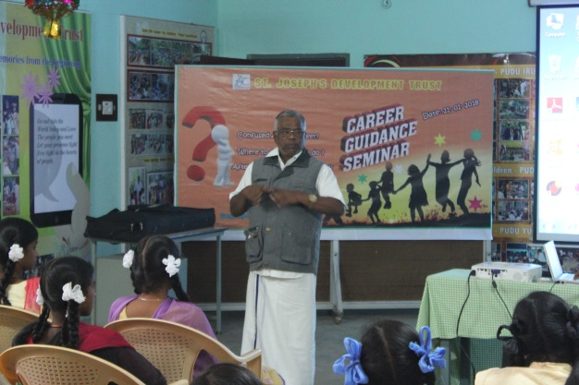
After such an inspiring and rejuvenating speech he started explaining the children about different possibilities of choosing their future/further studies after completing their grade 12. He elaborately explained the qualifications one should have to pursue particular course, scholarships offered during the course and the job opportunities available on completing these courses. The children were as attentive to this class as this is so important to set their goal and move towards achieving it. He also mentioned that there 33 branches in medical field. The children were not quite sure about different options available for them after completing their schooling. They focus only on few courses like some degree courses, engineering and some nursing. But Bro. Doss has opened their minds to think big and broad and they can choose their future. They can analyze which course can be fitting for them considering their family condition, educational performance and other factors as well. Once the session was over the children were given few minutes to interact with the presenter to ask if they have any doubts regarding his presentation. The summery of his presentation is attached as Annexure-1.
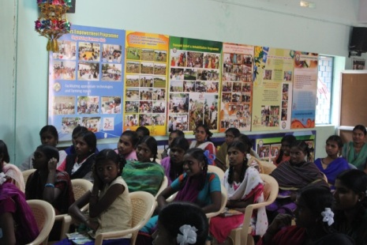
Ms. Deepa:
Ms. Deepa, one of our accountants had a presentation for about half an hour after the first session. She at the outset asked about how many of the participants wanted to become an accountant. Some of them raised their hands. She started sharing her own experience how she got into this life. She narrated different paths she had to travel to reach this far. She then went on explaining different courses connected with accounting. She also gave an explanation about accountability (account + ability) meaning ability to keep account of what you are given. She also urged the children to learn computer well along with typing skill and Tally software because the account system keeps changing and the aspiring children are to update themselves according to the changes. Some of them are very much inspired to become Charted Accountants (CA) without exactly knowing proper procedure to enter into it. She was able enlighten the children much better than anyone else in this regard. She clearly explained how hard it is to reach that position but she boldly mentioned in spite of difficulties it is always possible to reach. It was another eye opening session for many of the children who attended this class.

Staff from Devangar Polytechnic College:
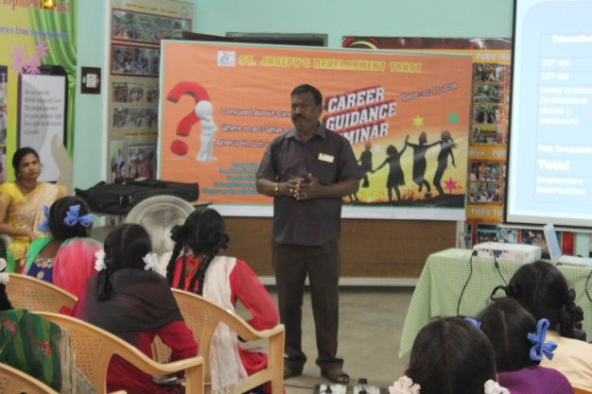
Three staffs arrived for this seminar as presenters from Devangar Polytechnic College, Devathanapatti which is about 10 km away from our institute. They divided their sections and presented in turns.
Firstly Mr. Sekar presented the present scenario and how hard it is to get a government job. Thus it is important that students become self-employable. So he urged the students to choose wisely and get a right course after completing their grade twelve. He also explained different courses offered and some of them are exclusively for boys in other colleges but they encourage girls also to choose such subjects. Once he completed his presentation everyone had a break to refresh themselves with tea and snacks.
The next presenter was a lady who is the Vice Principal of the college. She shared her own experience of how she chose a group which was promising in the beginning and when she left the college completing her studies it wasn’t promising anymore. As a girl she struggled hard to reach this position. She also believed that self-interest and courage fight for their desire will definitely bring anyone to the height they want to reach.
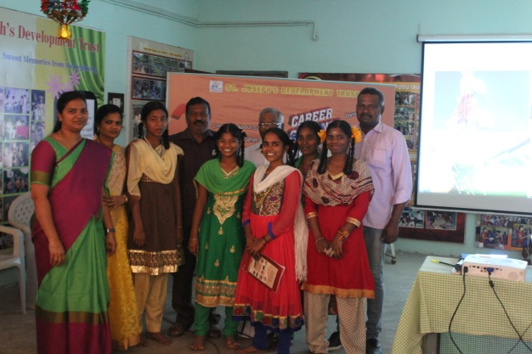
Finally Mr. Murugananthan dealt the session. He earlier worked as an accountant in our own institute and now he works chief accountant faculty in Devangar Polytechnic College. He explained to the students different schemes, scholarships provided by the government and also from the management side as well. All their presentations are attached as Anexure-2.

Dr. Siva, Physiotherapist, Periyakulam Government Hospital:
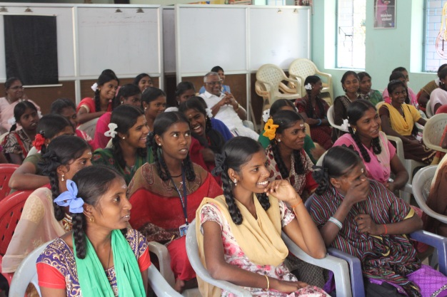
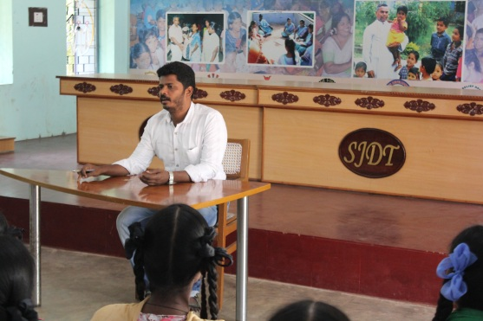
Dr. Siv is presently working as physiotherapist in Government Hospital in Periyakulam. He was previously working in PudhuUdhayam doing the same profession. So when we approached him to handle a session about his success and give the children some tips to achieve something big he delightfully accepted our invitation and came over here. He started the session sharing his own life experience, the amount of struggles he had gone through to reach such a decent position. He also urged the students that they can duly repay the institute by achieving a good position in their lives and start supporting children in need in their future. His presentation was not only of inspiration but also very touching. In the end he promised to support financially to complete their studies as many children as possible who get into medical line by scoring good marks. This promise definitely brought a great enthusiasm in the children. It was really good gesture from his side and everyone was delighted to hear such words from him.
Sr. Soosai Mary’s Presentation:
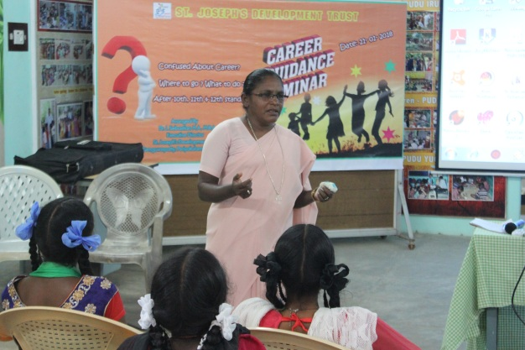
The program was behind the scheduled time and thus this class was shortened. She started with an ice breaking game as all three hostel children were present for this seminar. Once the game was over she again gathered the children in the hall and conducted another game. It was focusing on the memory status of the children and how sharp they listen to the instructions given. Through the game she educated the children to be attentive to the questions asked in the question paper and recollect exact answers for them.
With this session the children were left free for lunch. The children had sumptuous and refreshing meal so that they can be active and vibrant in the afternoon session as well.
Mr. Muthu Ganesh’s and Mr. Sivanraj’s presentation:
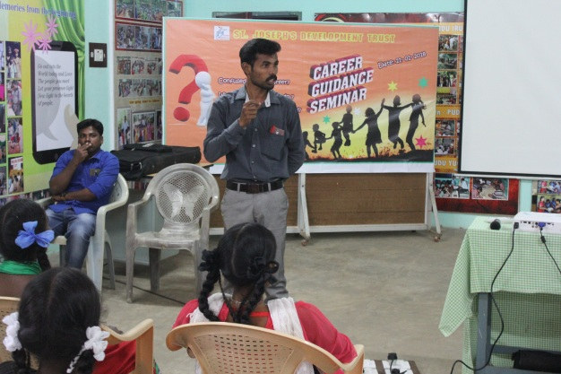
The afternoon session was started by Mr. Muthu Ganesh. He is the Director for SAI Academy, Batlagundu. This academy trains students for TNPSC (Tamil Nadu Public Service Commission) competitive exams, IAS, IPS and Military Service. He has enough experience to lead and give an idea about the future the children can choose for themselves.
He emphasized that talent depends upon the knowledge and not the size. The students are not to feel sorry for the losses they had experienced in the past but to have the win-win attitude. If one fails once he/she should have the attitude to win the next time.
With those words of encouragement he few more techniques to how to prepare themselves for the examinations.
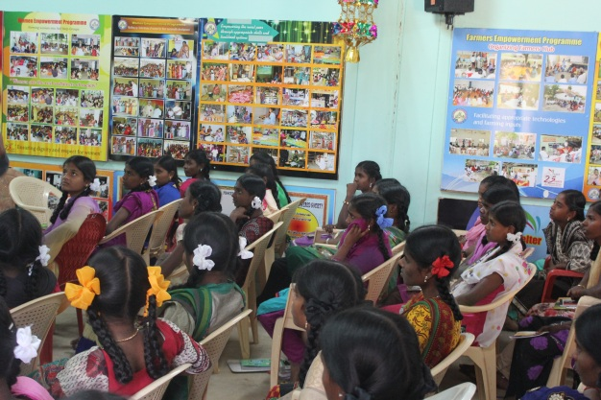
- Many students don’t like particular subject precisely because they don’t like the teachers who handle those subjects. Thus he advised the students to like the teachers primarily and eventually they will start liking the subject too.
- He advised them to start from today and never is too late to begin something good.
- Don’t say reasons for not doing your work (preparation for examinations)
- Don’t look for loopholes and chances to skip study hours
- Presentation of examination paper is very essential ( in this topic he explained how to present neatly the exam papers so as to attract the evaluator or examiner)

Mr. Sivanraj has explained different short term courses available in the current scenario that will make the students to prepare themselves and get a job quickly and settle in life. He pointed out
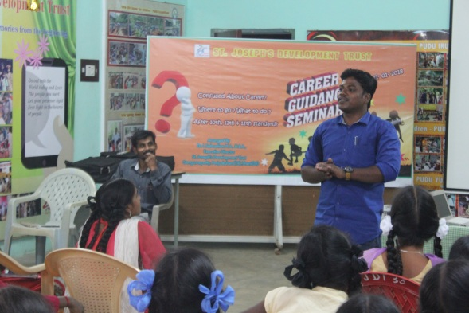
- Medical Electronics
- MRI Scanning
- Lab Technician and etc.
He elaborately explained about the process of getting into these branches. He also highlighted the politics and frauds involved in private training centers claiming to be genuine one. He skillfully handled the session the participants were all very much impressed by these two.
Bro. Arulsamy’s Class:
His presentation was short but vital. He has been in teaching field for quite many years and worked as Headmaster in different schools. He has also gone for Public Examinations evaluation a lot. Thus it was very important that he shares his knowledge, experience and expectation as an evaluator.
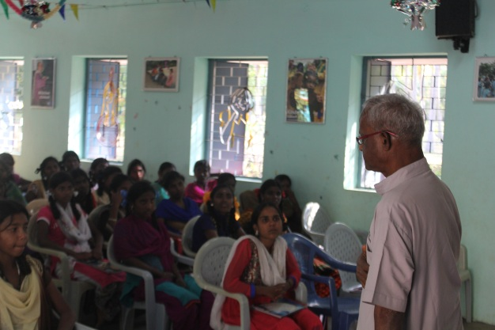
He quoted the saying of Dr. A.P.J. Abdul Kalam and that is “Dream is not that you see in sleep, dream is something that does not let you sleep”. He urged the children to aspire and aim high and work towards succeeding the target. He also advised the children to choose their department of profession and be faithful to their decisions. With these words he wound his class.

Mrs. Shanmugavalli’s and Ms. Joseline’s Presentation:
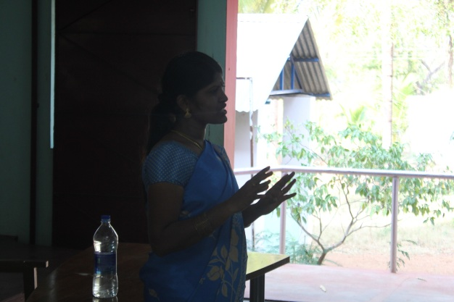
Mrs. Shanmugavalli started the session sharing about her own life stories. In spite of struggle she managed to her Master’s Degree and could work decently in our institute. She mentioned that the children have to work hard in order to achieve their dream. She also advised them to be aware of fraud institutions those promise to do many things but eventually do nothing. She shared the experience of two of our children who are caught up in bad situation. Her sharing was a kind of caution to the children.
Then Ms. Joseline came forward to share her experience as teacher. She gave few tips to children so that they can score good marks in the Public Examinations and have a great plan for their career. With her presentation the day came to an end.
Evaluation:
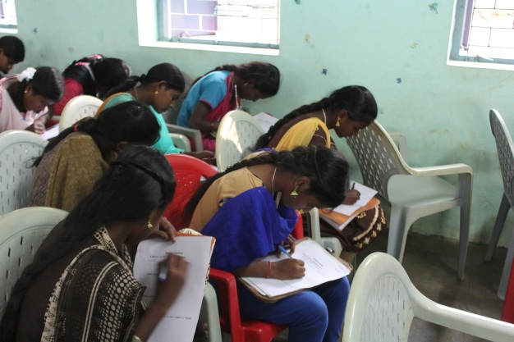
At the end of the day the children were given two sets of questionnaire which is a kind of feedback. The questions were about their learning from the particular day, their goal, what are the steps they are going to take to accomplish their dream and the support they need from the institute. It was asked to give their opinion about the program and how this sort of programs can be improved further in the coming days. The children sincerely did their work and have given their feedback genuinely.Then the children were provided tea and biscuits to refresh themselves before leaving the place.
Conclusion:
Correct direction is very important for everyone to reach a good level. However talented one might be but the guidance matters a lot. This day has brought that awareness, guidance, ideas about their future to all those participants. The children could feel that it is not late yet to actualize their dream. They still can work hard and achieve. That is the spirit the children had at the end of the session. For some of them they have a year or two go before they choose their correct career or studies related to their career. This program has definitely brought a great impact in all those who participated. The children expressed their sincere gratefulness to our Executive Director Dr. I. Sebastian for arranging such a wonderful and important program for the welfare of the children.
